TASK 8 – Trace the Compilation Process
8.1 Compilation commands
Use task05_debug.c and billing.h from Task 5.
Preprocessing:
This expands macros and processes header files and conditional compilation.
Generate assembly:
This generates assembly code.
Generate an object file:
This compiles the source into an object file without linking it into a complete executable.
Link and create an executable:
Compile with warnings enabled:
8.2 Error types
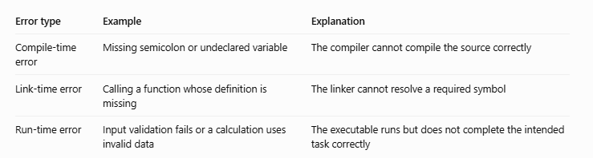
Compiler warnings should be reviewed and corrected where possible. A warning about an incorrect format specifier, unused variable, or suspicious conversion can indicate a genuine bug.
8.3 Alternative concept and complexity analysis
If the project were split into input.c, tariff.c and report.c, each source file could be compiled separately, with common declarations placed in a shared header.
Example:

In a single-file program, changing any part generally requires recompiling the source file. In a multi-file project, only the changed source file and affected dependencies may need recompilation, followed by linking. Separate object files use additional disk space, but can reduce build time as the project grows.
Conclusion: A single source file is easier for a small assignment. Separate files are more maintainable for a larger billing system.

